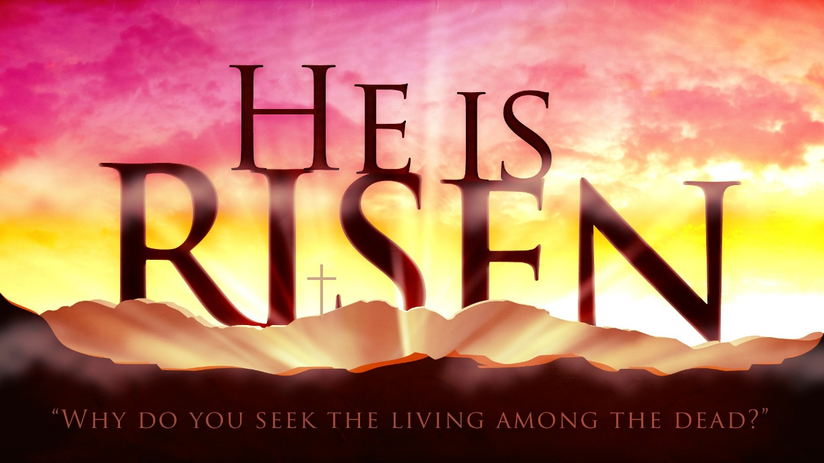
Why Do You Seek the Living Among the Dead?

2026 Upstate NY Church of God Resurrection Breakfast
King’s Catering & Party House
April 4, 2026
10 AM

Welcome: Russ Willemsen

Praise & Worship: William Whitley Sr.
William Whitley Jr.

Prayer: Robert Santiago: Men Dwelling in Unity
William Whitley Sr: Men Becoming Biblical Fathers
Deandre Moye: Men Of The Harvest
Antonio Gomez: Men Believing In God’s Provision

Scripture Readings: David Figueroa (Resurrection of Lazarus)
First Messenger of the Resurrection (John 20:11-18)
DonnaMarie Willemsen – in English
Maribel Figueroa – in Spanish

Praise & Worship: William Whitley Sr.
William Whitley Jr.

The Gospel Message: Bishop Dr. Steven Smith

Altar Call & Decision Making

Benediction: Leon Williams

